Industrial Casters-
Full Range
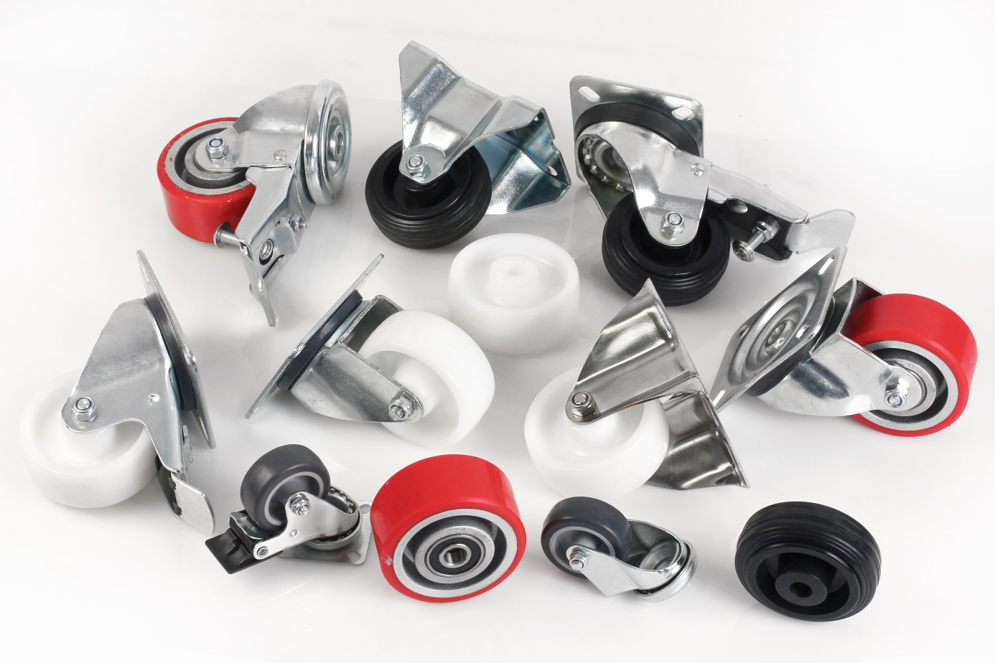

Engrenages HPC has expanded its range of casters to meet a widening range of industrial applications. Available in either steel or stainless steel, the castors are available in several formats:
Fixed with a top plate
Swivel with a top plate
Swivel with a top plate and dual brakes
Swivel with a central mounting hole
Swivel with a central mounting hole and dual brakes

The casters are able to support medium to heavy loads depending on the model. The exact model can be selected to suit the different types of floor (smooth or rough) on which it is to be used and the maximum load capacity required.

The smooth rolling red wheels are ideal for rough floors and can be used in the presence of swarf, solvents, oil, grease... The models with rubber tyres are preferred where shocks and vibrations are to be avoided and will not leave marks or marks on the ground. Stainless steel castors with polyamide wheels are ideal for use in damp and dirty environments (fish or meat preparation areas, canning facilities...).
In addition to the casters, Engrenages HPC can also supply the wheels separately.

