Complete range of right angled gearboxes
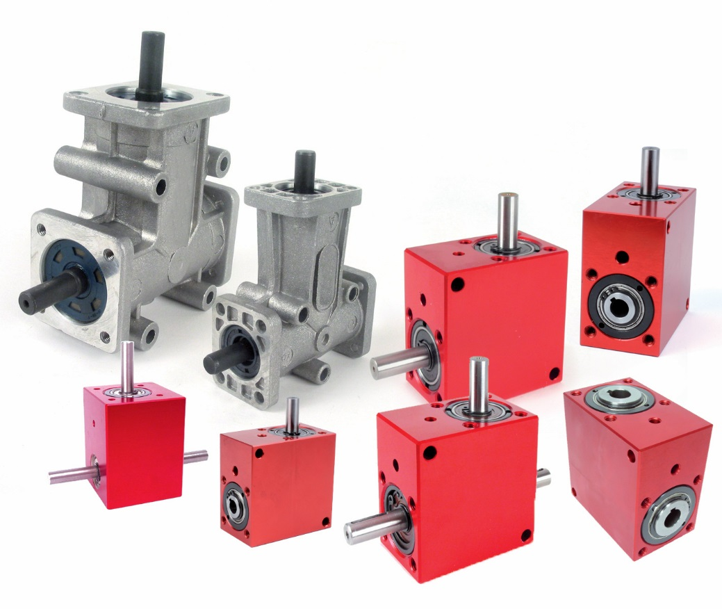

Engrenages HPC has a complete range of angled gearboxes that for a wide range of industrial applications where a change of direction of 90° between two shafts is required. A wide range of reduction ratios and choice of output shafts offer a numerous wide range of possibilities.

Two standard ranges are available in the HPC catalogue. The BLH, BLHT or BLHB models have smooth moulded anodised aluminium housings that are both robust and avoid any dirt retention. The CHTRB or CHTRP angled gearboxes have cast aluminium housings and offer an excellent price/performance ratio. All models are available in several different sizes and have maximum input speeds of between 2,000 and 4,000 rpm. Depending on the type of output shaft selected, the direction of rotation is either the same or reversed.

The majority of the L and T style gearboxes with ratios from 1:1 to 4:1 and with hollow, bored or mixed shafts, are available from stock for quick delivery. To meet the requirements of special applications where modifications are needed (shortening a shaft, changing diameters, alterations to the housing...), and subject to the model chosen, Engrenages HPC is also happy to supply custom built gearboxes.

