Pressed steel and stainless  
 steel bearings

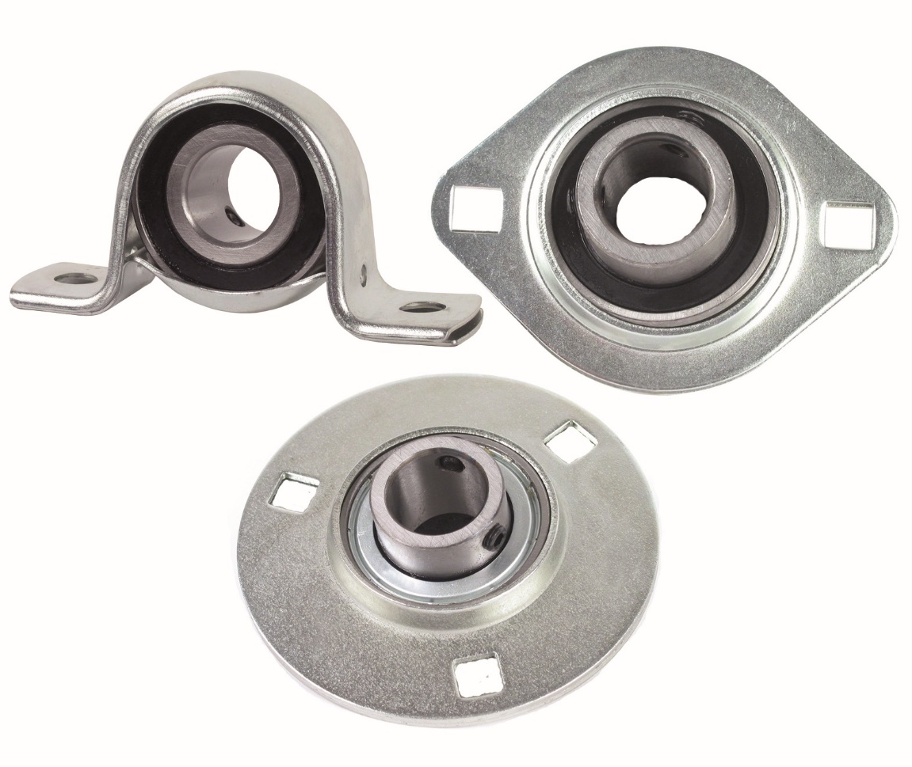

This new range of sheet metal bearings marketed by ENGRENAGES HPC are complete, ready-to-install units consisting of self-aligning bearings in either surface-mounted or cap-type housings. These bearings compensate for misalignment of the shaft and are self-aligning as they have ball bearings that are in radial contact with large inner rings and sealing gaskets. The flanged housings have 2 or 3 mounting holes, the cap bearings have a base plate with 2 mounting holes.

The range of steel bearings has been extended with new stainless-steel models. These bearings have the same technical characteristics as the steel versions but are protected against corrosion as the bearings and cage are entirely made of stainless steel, these bearings are therefore suitable for industries where corrosion criteria must be met. They are particularly ideal for use in aggressive environments.