New 3D Printing Service

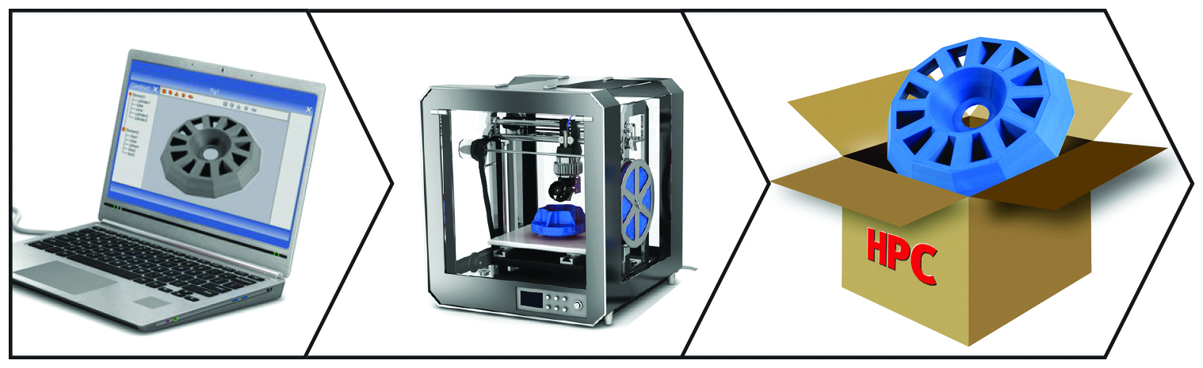
Always at the cutting edge of technology, HPC is now offering a new additive manufacturing service. If you cannot find the part you need from our extensive range or you need make a prototype of a new product, whatever your 3D printing project is, HPC can simplify your life and take care of the 3D printing for you.

The first part of the 3D printing process is the choice of material, there is a wide range available: Acrylate or epoxy resins, sintered plastic powders, deposited plastic filaments, metals ...
Then there is the choice of technology, several are available depending on what the desired result is. The first technique is manufacturing by deposition of molten material such as plastic filaments (FDM) which is the technology best known to the general public. This technology is typically now the cheapest and is suitable for manufacturing a large part of parts but it does not give the highest quality results. The second is laser selective powder sintering technology (SLS). This uses a bed of plastic or metal powder, which is fused layer by layer by a laser and thus creates the object required. The third and final technique is 3D Stereolithograpic (SLA) printing which is the technology most often used for creating prototypes ...
Based on the information contained in your 3D CAD file (e.g. STL), our technicians will select the best service provider at the best price, adapted to the type of printing and result that you require.

