Rollers
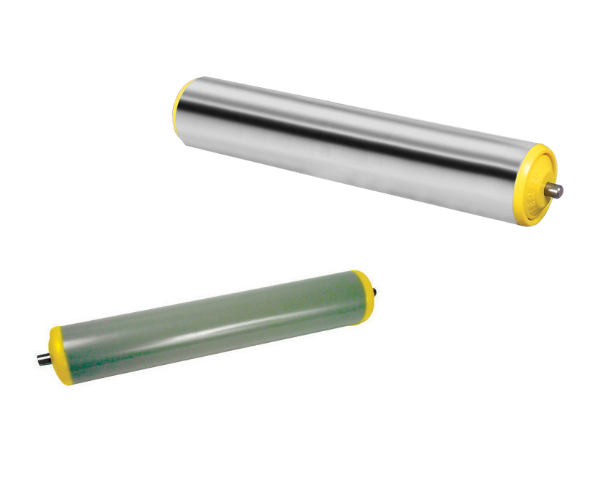

Engrenages HPC now offers two new roller models for gravity conveyor machines in its catalogue.

The plastic version is mounted on ball bearings is available in 20 and 50mm diameter and in lengths from 217 to 626mm. 20mm diameter plastic rollers are ideal for transporting small packages. For heavier loads, 50mm diameter rollers in either plastic or steel, are preferred.

The 50mm diameter steel version is mounted on oiled tapered steel bearings and is available in lengths from 326 to 776mm.

Many sizes are available from stock.

