Hygienic Usit® and
Hygienic Design® components
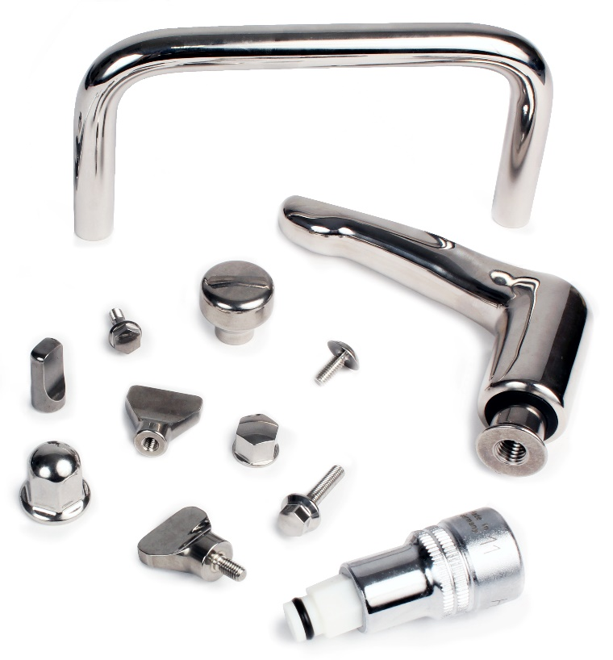

In order to meet the ever more demanding needs of the food, pharmaceutical and chemical industries, HPC Gears has expanded its range of stainless-steel components. All of the products in the Hygienic Design® and Hygienic Usit® ranges are made from stainless steel and are specially designed to ensure impeccable hygiene and easy maintenance.

The term "Hygienic DESIGN®" refers to standardised design rules for machine elements and components. Hygienic DESIGN® elements have smooth surfaces, so that germs, product residues and other impurities can be removed very easily. All curves, transitions and chamfers have also been designed to avoid retention of humidity so that they are also kept in an appropriately clean condition.

Hygienic USIT®" products are patented and protected stainless steel (A4) components. Screwed fasteners used in food technology plant construction have to be completely tight and easy to clean. Cavities where residues or cleaning liquids can collect unnoticed must be prevented as these are breeding grounds for germs and bacteria. Contamination is often only a question of time.

In summary, “Hygienic DESIGN®" and "Hygienic USIT®" components have respectively smooth surfaces that guarantee hygiene and facilitate cleaning. Dirt and residues from products or cleaning material are unlikely to adhere to "Hygienic DESIGN®" components. With "Hygienic USIT®" elements, all impurities will slide off, nothing can adhere or accumulate and so nothing can germinate.

The Hygienic USIT® range consists of sealing washers, cap nuts and bolts, male and female indexing handles, handles with integrated support washers, mushroom headed buttons. These fixing elements must be used with their corresponding washers to ensure there are no inaccessible cavities.

The Hygienic DESIGN® range includes butterfly nuts, cap screws and nuts, and lock washers. They are EHEDG certified and approved for the food and pharmaceutical industries. By using screws, nuts and lock washers together, the elements remain fixed and meet the requirements of the European standard 2006/42/EG.

For the correct assembly of these components, special tools are also available. They are specially designed for tightening and loosening threaded connections that have sensitive surfaces.

