Trapezoidal leadscrews and nuts.
Full range
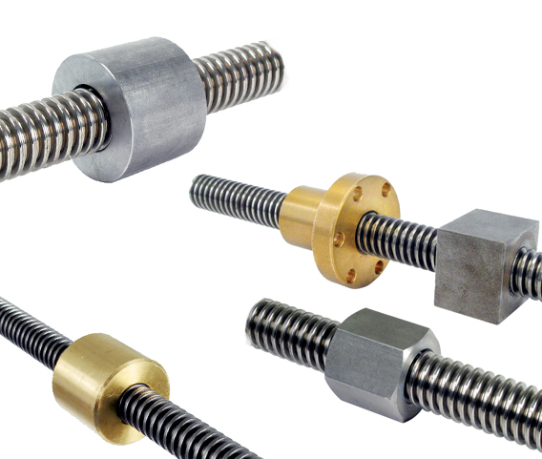

ENGRENAGES HPC offers a complete range of trapezoidal leadscrews and nuts. The leadscrews are available with a single thread inclined to either the right or left, two right handed threads and a double handed thread, i.e. a leadscrew where one part of the thread is right handed and the other left handed. The threads, which conform to ISO 2901 / 2903, have an excellent surface finish and allow very high forces to be transmitted.

In addition, matching nuts of all shapes (square, cylindrical, shoulder, hexagonal) and materials (polymer, steel, bronze) are also included in the range. Matching a trapezoidal leadscrew with the corresponding nuts allows an economical drive system to be assembled that has a high load capacity and that is easy to install.

The numerous models available from the HPC catalogue makes it possible to find a solution for all applications; manual or motorised control, low and medium rotation speeds, working under loads, etc.). These drive screws are perfectly suited for use machine tool applications such as lead screws for lathes, or in the case of 1 thread screws to lift a load safely thanks to their irreversibility (under conditions).

